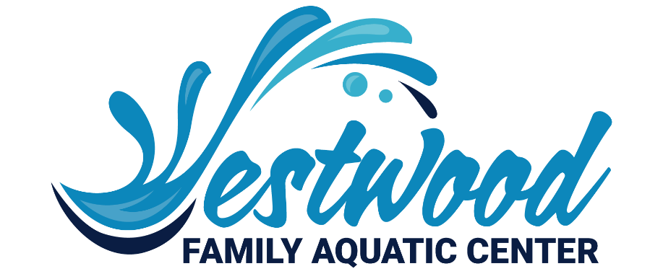

AMERICAN RED CROSS LIFEGUARD INSTRUCTOR COURSE
September 12-15, 2019 8am-5pm Cost: $200* + $37 Registration Fee to ARC

The Registration Link is: https://classes.redcross.org/R/class000000008048600/36232WFAQC

AMERICAN RED CROSS LIFEGUARD TRAINING COURSE
September 13-15, 2019 9am-4pm Cost: $175*

*Credit Card payments subject to 3.5% Processing Fee

Class to be held at Westwood Family Aquatic Center, 2400 Westport Ave Norman OK.
Questions?? Contact Carole Valentine at carole.valentine@normanok.gov or 405-802-8655

